Automated Multi-Section Academic Timetable Generation Using Constraint Optimization
Rahul K M
Dept of Computer Science and Engineering
Presidency University
Bengaluru, India rahumkm0424@gmail.com

Dr Shaik Salma Begum Assistant Professor,
Dept of Computer Science and Engineering
Presidency University
Bengaluru, India
shaiksalma@presidencyuniversity.in
Bhargavi N
Dept of Computer Science and Engineering
Presidency University
Bengaluru, India
bhsrgavibhargavi@gmail.com

Bhargavi K
Dept of Computer Science and Engineering
Presidency University
Bengaluru, India
anandanandareddyk@gmail.com

Abstract— Academic timetable generation is a complicated combinatorial issue which involves the fulfillment of several. institutionalities and yet not causing conflicts between subjects, faculty. time slots, members, and time slots. In this paper, an automated method of is given. generation of multi-section academic timetable based on constraint optimization. The scheduling problem is represented as a Constraint Satisfaction Problem (CSP) and solved with Google OR-Tools CP-SAT solver. The system is very strict in imposing. hard constraints, such as precise allocation of hours per week subject, single-subject-per-slot assignment, cross-faculty prevention of conflict. sections, and time-slot limitations of an institution. In addition, a subject difficulty metric puts priority of time in subjects that are cognitively challenging. periods. An over-constrained step is found during a pre-solve feasibility validation step. scenarios before optimization. The proposed is experimentally evaluated and has been found to be successful. approach creates conflict-free and scalable schedules and goes a long way in doing so. cutting down on manual scheduling.
Keywords—Academic Timetabling, Constraint Optimization, Constraint Satisfaction Problem, CP-SAT Solver, Combinatorial Optimization, Multi-Section Scheduling.

Introduction
Automated academic schedule generation is a combinatorial optimization problem which has been used to designate subjects and faculty to restricted time segments and also meet institutional limitations. Shared assignments of faculties, set subject hours and hard time slot policies are some of the issues that pose a great deal of complexity in scheduling in multi-section academic settings. Preparation of time-tables manually is time consuming and it may lead to conflicts and inconsistencies. Academic timetabling can be modeled as a Constraint Satisfaction Problem (CSP) due to its NP-hardness. In contrast to heuristic or rule-based methods, they may indeed be incapable of imposing all the necessary constraints in very constrained environments. A deterministic alternative is the constraint optimization and constraint programming techniques, which enable systematic execution of hard constraints, and efficient search through the possible solutions of the scheduling. The proposed system deals with the shortcomings of the current methods by combining constraint optimization, subject difficulty-aware scheduling, and pre-solve feasibility checks. This approach provides an efficient and scaled system of automated multi-section academic timetable creation.

Problem Statement
Multi-section academic timetable generation automation involves assigning subjects and faculty to time slots available, and meeting institutional scheduling constraints. Shared faculty Rigid subject-hour assignments, and restricted time slots in such environments contribute greatly to the complexity of scheduling. Manual scheduling systems are cumbersome and usually lead to a conflict of the faculty, duplication of classes and workload imbalance. Officially, every subject has to meet the following hard constraints:
- Do all the necessary weekly hours of subjects.
- avert faculty battles in various departments.
- One subject per time slot of section.
- Adhere to the policies of institutional scheduling.
Any contravention of any of these constraints leads to an infeasible timetable. Thus, an automated and structured system of scheduling is needed that would create conflict-free and institutionally approved schedules and manage a variety of sections and faculty assignments in an efficient way.

Objectives of the Proposed System
The proposed system aims to provide a deterministic and scalable solution for automated academic scheduling in multi-section institutions. The key objectives are:
- Generate automated multi-section academic timetables without conflicts.
- Model the timetabling problem as a Constraint Satisfaction Problem (CSP) suitable for computational optimization.
- Enforce hard constraints, including weekly subject hour requirements, single-subject-per-slot assignment, and prevention of faculty conflicts.
- Integrate subject difficulty prioritization to distribute cognitively demanding courses across suitable time slots.
- Include a pre-solve feasibility validation step to detect over-constrained scenarios before optimization, improving system reliability and efficiency.
These objectives collectively ensure efficient, accurate, and institution-ready timetables for modern academic environments.

Related Work
Academic timetable generation is an NP-hard combinatorial optimization problem with multiple constraints, including faculty availability, classroom allocation, and subject hour requirements [2]. Early deterministic and constraint-based approaches [1], [6] ensured strict rule compliance but often suffered from limited scalability. Methods such as tabu search [10] and Benders’ partitioning [11] improved computational efficiency for larger scheduling instances while preventing conflicts.
Metaheuristic algorithms, particularly genetic algorithms (GA), are widely used to address complex scheduling scenarios. Examples include guided and local-search genetic algorithms [12], student-preference-aware scheduling models [4], and hybrid hyper-heuristic approaches [13]. Particle swarm optimization (PSO) and other population-based techniques have also been applied to resolve faculty and classroom conflicts while maintaining scheduling constraints [7]. Standard benchmark datasets, such as those from the International Timetabling Competition, provide widely accepted evaluation frameworks for comparing different scheduling approaches [9].
Current research has integrated contemporary scholarly needs, such as hybrid classes and focus on cognitively challenging courses [3], [5], [8]. Other sophisticated optimization methods involve genetic algorithms grouping [14], lab scheduling techniques [15], large scale GA improvements [16], and memetic algorithms [17]. The studies of timetabling that are fairness based have also worked with the distribution of equitable workload allocation among the faculty members [18]. New developments in constraint programming and SAT-based optimization have brought forth the power of solvers like the CP-SAT framework that allows the modeling and solving of many complex scheduling problems efficiently [19]. Although these methods have been developed, most of the current methods are more of a heuristic optimization or feasibility generation methodology without incorporating pre-solve infeasibility detection and pedagogically-informed scheduling policies into a single framework.
TABLE I
COMPARISON OF EXISTING ACADEMIC TIMETABLING AND PROPOSED APPROACH
Algorithm / Approach | Key References | Strengths | Limitations
Constraint-Based Reasoning | [1], [6] | Ensures strict constraint compliance; deterministic solutions | Slow for large-scale problems; less flexible to changes
Tabu Search | [10] | Avoids local optima; handles large search space | Requires careful parameter tuning; may not guarantee global optimality
Benders’ Partitioning | [11] | Efficient decomposition for large-scale timetabling | Complexity in problem partitioning; setup overhead
Genetic Algorithm (GA) | [4], [12], [14]–[16] | Flexible; handles complex constraints; allows soft/hard constraint prioritization | Convergence depends on population size; may need hybrid strategies for high-quality solutions
Particle Swarm Optimization (PSO) | [7] | Fast convergence; effective for resource allocation | Can get trapped in local optima; parameter-sensitive
Hyper-Heuristic / Hybrid GA | [13], [17] | Combines global and local search; adaptable to different problem instances | Computationally intensive; may require tuning of multiple heuristics
CP-SAT Optimization (Proposed) | – | Deterministic, conflict-free, scalable; supports pre-solve feasibility and subject prioritization | Requires formal CSP modeling; solver performance depends on problem size

The comparison reveals that the current approaches tend to be poorly deterministic, pre-solve solvency and multi-section scalable. The suggested automated multi-section academic schedule generation system deals with these shortcomings by incorporating constraint optimization, pre-solve feasibility checks, and subject difficulty-based scheduling.

System Architecture
The proposed system is an automated academic timetable-generation system, which is a modular pipeline which integrates data preprocessing, constraint modeling, and optimization. All modules have a particular purpose that would guarantee effective planning and control of the rules of the institution (Fig. 1).
A. Data input Layer: The input layer is where academic data is inputted by the administrators in the form of subjects, faculty members and weekly hour requirements. The inputs are saved in a tabular CSV format (e.g., Subjects.csv and Faculty.csv) that contains all the subject codes, subject names, and hours needed, and a faculty subject combinations. Such a systematic approach will ensure that it is compatible with the preprocessing which will be done afterwards and will facilitate easier data processing.
B. Data Preprocessing and Validation: The data preprocessing module guarantees the input data is correct and consistent through validating and converting the data. Checks: •
(a) Checking the minimum hours of teaching.
(b) Checking of free time period.
(c) Checking of faculty-subject assignments Difficult or resource-intensive subjects receive priority scheduling, to improve the overall schedule.
C. Subject Difficulty Analysis: This module will assess subjects in terms of teaching hours, faculty presence and complexity of schedule. High-difficulty subjects are given the first priority in the schedule, and conflicts are reduced to the maximum extent, and there is a fair distribution of time between the available slots.
D. Constraint Modeling Layer: It is a layer where the scheduling rules and institutional policies are mathematically expressed. Constraints include:
• Time slot availability
• Faculty assignment restrictions
• Weekly subject hour requirements.
• Faculty conflicts prevention. Other limitations, like desired morning sessions, can also be integrated so as to improve the quality of the schedule.
E. Optimization Engine: The system is based on the Google OR-Tools CP-SAT solver to search through feasible schedules that meet all the hard constraints and optimize the efficiency of scheduling. The solver tests various combinations of subjects, faculty members and time slots. A time-sensitive search methodology makes large-scale instances of scheduling computationally efficient.
F. Solution Generation Module: After a viable solution is discovered, the solver output is translated into formatted schedules, such as section schedules and faculty schedules. The data is structured with Pandas DataFrames that enable the easy manipulation, exportation, and additional administrative analysis.
G. Data Visualization Layer: The last layer is a visual dashboard that has been developed with Streamlit. Users can view:
  - Section-wise timetables
  - Faculty assignments
  - Overall schedule structure
The dashboard promotes usability and allows efficient review and decision making by the administrators and the faculty members.
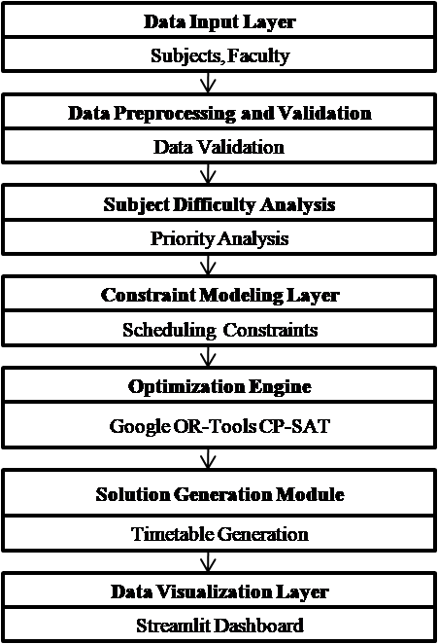
Fig.1. Design of the proposed automated generation of academic timetable system.

Methodology

The proposed system presupposes a systematic and predictable approach to automated creation of multi-section academic schedule based on the integration of constraint modeling, optimization, and feasibility checks. The approach is very institutional in terms of institutional scheduling policies and efficient and scaleable in multi-section educational institutions. It is developed on a variant of a V-Model, where each verification step corresponds to a verification step, and infeasible scheduling situations can be discovered early, and the overall reliability of the system can be improved.
A. Requirement Analysis: The initial one involves the collection of institutional data, including faculty data, subject assignments, classroom capacities and time-slot policies. There are constraints that are categorized into: o Hard constraints: certain hours of subjects per week, one-subject-per-slot, faculty conflicts and time slot policies of the institution.Soft constraints: preferable schedules, and equal distribution of subjects. These limitations inform the optimization process and make sure that the timetable is feasible and the academic quality is met.
B. System and Functional Design: There are three modules in the system architecture:
1. Data Preprocessing: Removes invalid and unwashed data.
2. Constraint Modeling: Converts institutional rules to mathematical constraints.
3. Timetable Generation with Optimization: Generates legal timetables by using optimization solvers.
The modular structure allows independent testing, provides future enhancements and allows a seamless integration of modules.
C. Constraint Formulation: Timetable generation refers to a Constraint Satisfaction Problem (CSP). Each section–day–time slot combination is represented using decision variables. The constraints coded are: o Accurate weekly allotment of hours in the subjects. o One topic in slot in section. o Restriction of faculty assignments to avoid conflicts. o Institutional time slot, breaks. Subject difficulty is also implemented as a soft constraint and cognitively demanding subjects are given duly time slots to maintain balance in academia.
D. Pre-Solve Feasibility Check: Feasibility check is made by the system before optimization to determine over-constrained conditions such as time slot lack, or excessive number of subject hours. The step avoids unwarranted calculation and offers early feedback to adjust a constraint.
E. Optimization and Timetable Generation: Timetables are, using a Google OR-Tools CP-SAT solver, created with conflict-free schedules. The solver gradually goes through the search space of the solution, testing all the hard constraints and maximizing the soft constraints to make the schedule better. Parallel search and time constrained solutions are used to increase computational efficiency.
F. Validation and Output: There are several levels of verification which ensure that the system is correct:
1. Unit Testing: Runs a test on each of the modules, e.g. data processing, constraint enforcement and solver functionality.
2. Integration Testing: Assures the smooth communication amongst modules.
3. System Testing: Checks end-to-end timetable creation.
4. Acceptance Testing: Verifies that it is in line with the institutional requirements.
The end product will consist of structured section-wise and faculty-wise schedules, which will be presented in table format to be used by the administration. This algorithm guarantees deterministic, scalable, and complete compliant timetable generation.

TABLE II
FEATURE COMPARISON BETWEEN EXISTING TIMETABLING METHODS AND THE PROPOSED APPROACH
Feature | Existing Timetabling Approaches | Proposed Automated Timetable Generation System
Hard Constraint Enforcement | Partial or heuristic-based, may allow violations | Strictly enforced via CP-SAT solver
Soft Constraint Handling | Limited; mainly handled by GA or PSO | Subject difficulty prioritization integrated
Pre-Solve Infeasibility Detection | Not available | Detects over-constrained scenarios before optimization
Multi-Section / Multi-Faculty Support | Varies; often limited | Fully supports multi-section institutions with shared faculty
Deterministic & Reproducible | Often non-deterministic due to heuristic methods | Fully deterministic schedule generation
Scalability | Moderate; performance drops with larger instances | Efficient for multiple sections with low solver runtime
Visualization & Usability | Typically absent | Integrated Streamlit dashboard for administrative review
Optimization Quality | Heuristic; may be sub-optimal | Produces high-quality, conflict-free timetables

MATHEMATICAL FORMULATION
The automated timetable generation problem may be modeled as a constraint optimization problem, in which the goal is to allocate subjects and faculty members into the available time slots with meeting the institutional and academic constraints. The sets, decision variables, constraints and the objective function to be used to formulate a feasible timetable are determined by the formulation.

Sets and Indices
Let the following sets represent the elements involved in the scheduling process:
- S={s₁,s₂,...,s_{n}}: Set of subjects
- F={f₁,f₂,...,f_{m}}: Set of faculty members
- C={c₁,c₂,...,c_{k}}: Set of academic sections
- D={d₁,d₂,...,d_{p}}: Set of working days
- T={t₁,t₂,...,t_{q}}: Set of available time slots per day
Additional parameters used in the formulation include:
- H_{s}​: required weekly teaching hours for subject s
- A _{s,f} : subject–faculty eligibility parameter, where
A _{s,f}​ =1 if faculty f can teach subject s, otherwise 0

Decision Variable
A binary decision variable represents whether a subject is assigned to a specific section, faculty member, day, and time slot.
 | $$x_{s,c,f,d,t}=\left\{\begin{aligned}1, if subject s is scheduled for \\ section c by faculty f on day d \\ at time slot t \\ 0,otherwise\end{aligned}\right.$$ | (1)
This variable determines whether a particular subject–faculty combination occupies a specific timetable slot.

Weekly Hour Constraint
Each subject must be scheduled for the required number of hours within a week. Let H_{s} represent the required weekly hours for subjects.
 | $$\sum_{f∈F}{\sum_{d∈D}{\sum_{t∈T}{x_{s,c,f,d,t}=H_{s,c }∀s∈S}}},c∈C$$ | (2)
This constraint ensures that every subject is allocated exactly the number of time slots required by the curriculum.

Faculty Conflict Constraint
A faculty member cannot teach more than one class at the same time slot.
 | $$\sum_{s∈S}{\sum_{c∈C}{x_{s,c,f,d,t}}}≤1 ∀f∈F,d∈D,t∈T$$ | (3)
This prevents scheduling conflicts where a faculty member is assigned to multiple sections simultaneously.

Section Time Slot Constraint
Each section can attend only one subject in a given time slot.
 | $$\sum_{s∈S}{\sum_{f∈F}{x_{s,c,f,d,t}}}≤1 ∀c∈C,d∈D,t∈T$$ | (4)
This ensures that a section does not have overlapping classes.

Faculty–Subject Assignment Constraint
A subject can only be taught by a faculty member who is assigned to that subject. Let A_{s,f} represent the subject–faculty eligibility matrix.
 | $$x_{s,c,f,d,t} ≤A_{s,f}$$ | (5)
This constraint ensures that only authorized faculty members are assigned to teach specific subjects.

Time Slot Availability Constraint
The system also respects predefined slot availability restrictions. If a time slot is unavailable for scheduling, assignments to that slot are not permitted.
 | $x_{s,c,f,d,t}=0$ for unavailable slots | (6)
This constraint allows institutions to block certain slots, such as lunch breaks or administrative periods.

Objective Function
The aim of optimization process is to produce a viable schedule that meets all the constraints and enhances the quality of schedules. The system gives precedence to hard subjects and allocates them effectively in the time slots available.
 | Maximize Z = $\sum{w_{s}x_{s,c,f,d,t}}$ | (7)
where ws is the weight of priority of the subject s. The subject-identified more difficult or critical is assigned higher weights in preprocessing. This motivates the solver to plan such subjects in the right time slot prior to the optimization process. With this formulation, a problem of generating timetables automatically is formulated as a constraint minimization problem, which is effectively solved with the CP-SAT solver in the OR-Tools framework.

Results and Analysis
The following section is the experimental test of the proposed Smart Classroom and Timetable Scheduler. The analysis targets the viability and scalability of the scheduling framework in the generation of academic schedules in environmentally realistic institutional constraints. The experiments aimed to investigate the ability of the system to generate consistent valid timetables, and understand how the solver evolves with the size of the scheduling problem.

Experimental Environment
The scheduling system was written in Python and run on the Google Colaboratory cloud service. The system uses a constraint-based optimization approach to derive conflict-free academic schedules and meet institutional constraints, including faculty availability, subject time slot allocation, and pre-established time-slot policies. In order to improve the interpretability of the results of the scheduling, an interactive visualization interface was created with the help of the Streamlit framework. With this dashboard, administrators can look at section-wise and faculty-wise timetables and monitor the solver behavior in a graphical format. The optimization process is conducted with the help of the CP-SAT solver of the Google OR-Tools library, which offers high-performance to large-scale optimization problems of constraints and guarantees the generation of reliable timetables.

Feasibility Analysis
The validity analysis was done to identify whether the proposed scheduling framework could be used to produce valid schedules that could always be used to meet all the specified constraints. The procedure of generating timetables was repeated 10 times with the same input configurations to test the reliability of the scheduling process. The solver runtime was recorded each time to determine how stable the optimization process was. The measured times of solver execution were between 0.13 seconds and 0.42 seconds on the ten experimental runs. Although there were slight differences in the time taken, the solver was capable of producing viable schedules in all the runs. The generated schedules met all the specified constraints, such as:
  - avoidance of faculty scheduling conflict.
  - prevention of duplication of classes in sections.
  - proper distribution of subject time.
  - compliance with predetermined time-slot limits.
Fig. 2 shows the results, showing the execution time of the solver in each experimental run. The observed changes in runtime are anticipated to happen because of the inner workings of the optimization solver like constraint propagation and search exploration as the optimization is going on. The fact that the model produces valid schedules at all runs indicates that the suggested scheduling model can be relied on to generate valid schedules in a very limited time of computation.

Fig. 2. Solver execution time (feasibility analysis) of several experimental runs.
C. Scalability Analysis
Scalability analysis was carried out to determine the working of the scheduling framework with increasing scale of the problem. The experiment was to add more and more academic sections to the timetable model, thereby adding more subjects, faculty and scheduling limitations. Each configuration was run several times and the mean run time was computed.
The results, illustrated in Fig. 3, show the relationship between the number of sections and solver execution time. The average run time was around 0.06 seconds with only one section in the model and the average run time was approximately 0.30 seconds with 6 sections. Though the runtime with problem size was increased because of the more problem variables and constraints, the increment was modest, which suggests that the offered scheduling framework can be characterized by an efficient computing performance in the case of larger scheduling problems.

Fig.3. Scalability testing indicating the average solver time of more and more problem sections.
These findings illustrate that the suggested scheduling model can be scaled to deal with more complicated academic scheduling problems without incurring a substantial computational cost.

Discussion of Results
The last deliverable of the proposed scheduling system is the automatic creation of section-based and faculty-based academic schedules. The CP-SAT solver then produces a conflict-free schedule that complies with all institutional constraints, such as the subject hour requirements, faculty availability and section time-slot constraints, after solving the constraint optimization model. The produced schedules are presented in the form of the Streamlit dashboard, and the administrators can easily read and check the structure of timetables. One of the generated section timetables is shown in Fig. 4, where the subjects are allocated to the available weekly time slots and at the same time that every section has only one subject at a given time slot and that the total hours of teaching that have to be met are met.
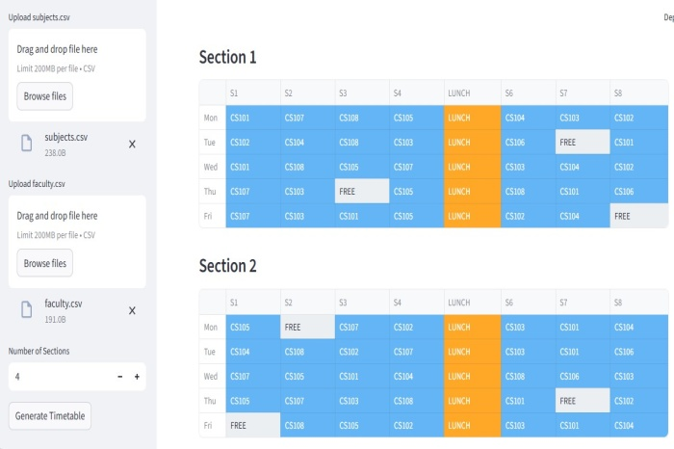
Fig. 4. Timetable that is generated section-wise by the proposed scheduling system. Besides section-level scheduling, the system will automatically produce faculty-level timetables that summarize the teaching assignments of instructors in various sections.
This representation aids administrators in ensuring that faculty members are not working on several classes at the same time and also enables easy tracking of workload allocation. The system produced the faculty schedule as shown in Fig. 5. These findings validate the claim that the constraint-based methodology designed can generate consistent and conflict-free schedules and yet remains efficient in terms of solver run time. The combination of optimization and a visualization interactive interface makes the system an effective tool that academic administrators can use to analyze and control institutional timetables.
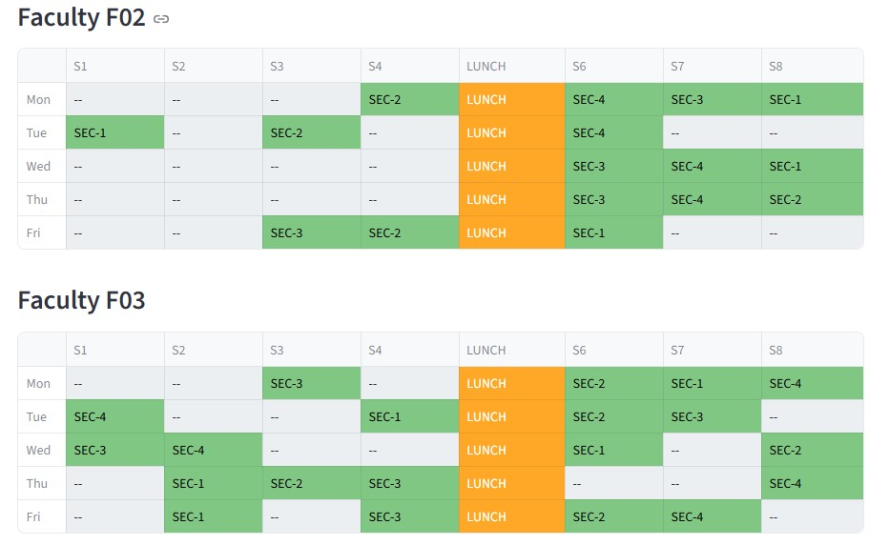
Fig. 5. Generated faculty-wise timetable showing instructor assignments across sections.

Conclusion
The suggested system is an automated system of generating academic timetable in multi-section institutions based on a constraint optimization. The problem of scheduling was modeled as a Constraint Satisfaction Problem (CSP) and solved with the CP-SAT solver of Google OR-Tools framework. The system can produce error-free and conflict-free timetables by adhering to hard constraints, like preventing faculty conflicts, correctly allocating subject hours weekly, and institutional time-slot policies. Subject difficulty prioritization also enhances the quality of scheduling by allowing a more balanced allocation of the more academically challenging subjects to the available time slots.
Experimental analysis shows that the suggested framework yields always viable schedules and requires the minimum solver execution time without varying performance with the size of the scheduling problem. System reliability is also improved with the incorporation of a pre-solve feasibility validation step that predetermines situations in which the optimization process is over-constrained. Future projects could expand the system to include other realistic constraints like classroom space allocation, equal faculty workload management, and dynamic timetable schedule adjustments to facilitate changing academic conditions.

References
[1] S. Deris, S. Omatu, and H. Ohta, “Timetable planning using constraint-based reasoning, ”Computers & Operations Research, vol. 27, no. 9, pp. 819–840, 2000. https://doi.org/10.1016/S0305-0548(99)00051-9
[2] A. Bashab, A. O. Ibrahim, I. A. T. Hashem, K. Aggarwal, F. Mukhlif, F. A. Ghaleb, and A. Abdelmaboud,
“Optimization techniques in university timetabling problem:
Constraints, methodologies, benchmarks, and open issues,”
Computers, Materials & Continua, vol. 74, no. 3, pp. 6461–6484, 2023. https://doi.org/10.32604/cmc.2023.034051
[3] J. García-Sánchez et al., “The university coursework timetabling problem: An optimization approach to synchronizing course calendars,” Computers & Industrial Engineering, vol. 184, 2023. https://doi.org/10.1016/j.cie.2023.109561
[4] A. R. Mahlous and H. Mahlous, “Student timetabling genetic algorithm accounting for student preferences,” PeerJ Computer Science, vol. 9, 2023. https://doi.org/10.7717/peerj-cs.1200
[5] X. Gu et al., “From integer programming to machine learning: A technical review on solving university timetabling problems,” Computation, vol. 13, no. 1, 2025. https://doi.org/10.3390/computation13010010
[6] S. Abdennadher and M. Marte, “University course timetabling using constraint handling rules,” Applied Artificial Intelligence, vol. 14, no. 4, pp. 311–325, 2000. https://doi.org/10.1080/088395100117016
[7] R. M. Chen and H. F. Shih, “Solving university course timetabling problems using constriction particle swarm optimization with local search,” Algorithms, vol. 6, no. 2, pp. 227–244, 2013. https://doi.org/10.3390/a6020227
[8] M. Davison, A. Kheiri, and K. G. Zografos, “Modelling and solving the university course timetabling problem with hybrid teaching considerations,” Journal of Scheduling, 2025. https://doi.org/10.1007/s10951-024-00817-w
[9] B. McCollum, A. Schaerf, B. Paechter, P. McMullan, and R. Lewis, “Setting the research agenda in automated timetabling: The second international timetabling competition,” INFORMS Journal on Computing, vol. 22, no. 1, pp. 120–130, 2010. https://doi.org/10.1287/ijoc.1090.0320
[10] R. Alvarez-Valdés, E. Crespo, and J. M. Tamarit, “Design and implementation of a course scheduling system using tabu search,” European Journal of Operational Research, vol. 137, no. 3, pp. 512–523, 2002. https://doi.org/10.1016/S0377-2217(01)00091-1
[11] S. C. Sarin, Y. Wang, and A. Varadarajan, “A university timetabling problem and its solution using Benders’ partitioning—A case study,” Journal of Scheduling, vol. 13, no. 2, pp. 131–141, 2010. https://doi.org/10.1007/s10951-009-0157-1
[12] S. N. Jat and S. Yang, “Genetic algorithms with guided and local search strategies for university course timetabling,” IEEE Transactions on Systems, Man, and Cybernetics Part C: Applications and Reviews, vol. 41, no. 1, pp. 93–106, 2011. https://doi.org/10.1109/TSMCC.2010.2049200
[13] Z. Zhang, H. Liu, and Y. Wang, “A hyper-heuristic algorithm based on genetic and greedy strategy for university course scheduling problem,” Applied Soft Computing, vol. 186, 2026. https://doi.org/10.1016/j.asoc.2025.114150
[14] B. Paechter and R. Lewis, “Application of the grouping genetic algorithm to university course timetabling,” in Proc. 5th European Conf. Evolutionary Computation in Combinatorial Optimization (EvoCOP), 2005, pp. 144–153. https://doi.org/10.1007/978-3-540-31996-2_14
[15] Z. Bratković, T. Herman, V. Omrčen, and D. Jakobović, “University course timetabling with genetic algorithm: A laboratory exercises case study,” in Proc. European Conf. Evolutionary Computation in Combinatorial Optimization (EvoCOP), 2009, pp. 240–251. https://doi.org/10.1007/978-3-642-01009-5_21
[16] S. Limkar, A. Khalwadekar, A. Tekale, M. Mantri, and Y. Chaudhari, “Genetic algorithm: Paradigm shift over a traditional approach of timetable scheduling,” in Proc. Int. Conf. Frontiers of Intelligent Computing: Theory and Applications (FICTA), 2014, pp. 771–780. https://doi.org/10.1007/978-3-319-11933-5_87
[17] S. N. Jat and S. Yang, “A memetic algorithm for the university course timetabling problem,” in Proc. IEEE 20th Int. Conf. Tools with Artificial Intelligence (ICTAI), Dayton, OH, USA, 2008, pp. 427–433. https://doi.org/10.1109/ICTAI.2008.126
[18] M. Mühlenthaler, Fairness in Academic Course Timetabling. Cham, Switzerland: Springer, 2015. https://doi.org/10.1007/978-3-319-12799-6
[19] B. Lennartson, “Optimization of timed Petri nets using CP-SAT,” IFAC-PapersOnLine, vol. 58, no. 1, pp. 90–95, 2024.
https://doi.org/10.1016/j.ifacol.2024.07.016

